A Brief History of the New Mexico Faceters Guild By [Ernie Hawes](file:///G:\Hawes.jpg), 5-16-01

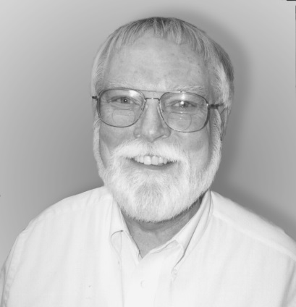In the spring of 1980, I attended the Albuquerque Gem and Mineral Club annual show.  I had been faceting, self-taught, for about six years.  I only knew one or two other faceters in our area, but felt there were probably more.  At the show, I found Eldon Fleck demonstrating faceting.  I spent quite a bit of time talking with him and finally asked if he would be interested in starting a faceting guild.  Eldon agreed to put out a sign-up sheet during the rest of the show.  Not much happened after that for almost a year.  Eldon had a few names on his list, but we just didn't connect up to get the ball rolling.  The next year, Eldon and I were both demonstrating faceting at the club show, and both of us had sign-up sheets.  On Saturday afternoon a big fellow stopped by my table and said "I've got a machine like that."  We talked.  I found out his name was Louis Natonek.  He signed my list and asked if we had a place to meet.  We didn't.  Louis said that he had a big converted double garage that we could use.  We got together after the show, and I put together our first "newsletter," which consisted of an invitation on a postcard to the twenty some odd folks who had signed up on our list.  To encourage attendance, I said we'd have a drawing for a nice piece of rough.  We held our first meeting in May, 1981 in Louis' converted garage. We had a good turn-out at that first meeting, and agreed to form a guild with all the accoutrements of a formal organization.  We continued to meet in members' homes for several months.  As our membership grew, we began to use public meeting rooms in a bank.  Eventually, we were invited to use meeting rooms in the New Mexico Museum of Natural History.  We had been a significant part of the Museum's first anniversary celebration and show of gems and minerals. We also had demonstrated faceting several weekends at the Museum.  Thus, the Museum has been our home for several years.  However, our first meeting place, Louis Natonek's garage, continued to be a gathering place for faceting workshops for almost twenty years.  Eldon Fleck passed away a few years ago and Louis died last month.

Over the years, our membership has grown and changed.  Some folks moved or lost interest.  New folks got involved, and they got others involved.  Albuquerque has a significant scientific population, and this is reflected in our membership.  I imagine that we have more PhD's in our guild than just about any other guild anywhere.  Consequently, The New Mexico Facetor, tends to have quite a few articles that deal with the scientific aspects of faceting. At least two of our members, Steve Attaway and Scott Wilson, have engaged in significant scientific research regarding faceting.  Steve and Nancy Attaway have also done significant work in using CAD/CAM programs in the design and creation of jewelry. You'll fiind many of these articles on our web pages,  [http://www.attawaygems.com/NMFG](file:///G:\\index.html).  The Guild also has a number of professional jewelers among our members.  Because of our scientific, museum and jeweler connections, we have been fortunate to have a number of outstanding speakers at our meetings, which are now held on the second Thursdays of the odd numbered months.

The New Mexico Facetor has grown from that first postcard to become one of the most widely distributed and read faceting publications in the world. Articles and designs originally published in The New Mexico Facetor are frequently reprinted in other guild publications around the world.  We have members across the United States as well as in Canada, Italy and Australia.  Over the years, we've also had members in Finland, England, and South Africa.  I edited the newsletter for several years, then assisted Merrill O. Murphy in the task.  For several years, now, Nancy and Steve Attaway have been very able editors.

Individuals interested in learning more about The New Mexico Faceters Guild should read our web pages.  [Membership](file:///G:\Membership_Form.html) [information](file:///G:\Membership_Form.html) may be obtained there, as well.