Long Cushion Triangle
By Ernie Hawes
Angles for R.I. = 1.760
61 + 18 girdles = 79 facets
1-fold, mirror-image symmetry
96 index
L/W = 1.272 T/W = 0.660 U/W = 0.519
P/W = 0.463 C/W = 0.180
Vol./W³ = 0.261

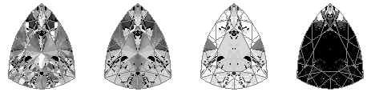

Random COS = 58.1 % ISO = 82.7 % Dispersion = 7.8 %
Scintillation = 48.8 %

PAVILION

1 40.50° 45-51
2 40.81° 46-50
3 46.15° 20-76
4 44.31° 15-81
5 45.25° 16-80
6 46.43° 19-77
g1 90.00° 46-50
7 43.17° 43-53
g2 90.00° 43-53
8 48.26° 21-75
9 44.24° 40-56
10 49.10° 23-73
g3 90.00° 40-56
g4 90.00° 23-73
g5 90.00° 21-75
g6 90.00° 19-77
g7 90.00° 16-80

11 45.45° 14-82
12 44.64° 11-85
g8 90.00° 14-82
g9 90.00° 11-85

CROWN

a 45.85° 23-73
b 45.35° 21-75
c 44.27° 19-77
d 42.59° 16-80
e 41.63° 14-82
f 40.59° 11-85
g 40.68° 40-56
h 40.23° 43-53
i 38.00° 46-50
j 36.31° 45-51
k 42.05° 20-76
l 39.61° 15-81
m 26.54° 96
n 31.61° 31-65
o 29.39° 48
p 23.39° 40-56
q 27.22° 23-73

r 32.72° 17-79
s 23.97° 11-85
T 00.00° Table

